Step-by-Step:

Working with CRM ZoHo Features

| September-20 |

**Document Overview**

**Documentation Goals**

This documentation is intended to provide instruction for ***using the CRM ZoHo system****.*

**Table of Contents**

**Set Up Advantzware CRM ZoHo Account** 3

Log In to ZoHo 3

Active Authtokens 3

Advantzware System – Customer Maintenance 5

Open Customer File Maintenance Screen 5

CRM Icon 5

N-K-1 CRMAuthToken 6

Paste AuthToken 7

ZoHo Accounts 7

Select Account 8

Repeat as Necessary 8

Return to Customer Maintenance 9

Open Customer File Maintenance Screen 9

CRM Icon 9

ZOHO CRM Customers 9

**Set Up Advantzware CRM ZoHo Contacts** 11

Locate Customer in ZoHo 11

Advantzware System – Customer Maintenance 11

Open Customer File Maintenance Screen 11

Phone Info Icon 12

CRM Icon 12

ZOHO CRM Customer Contacts 13

**Advantzware Open Analytics (AOA)** 15

Auto Upload CRM Accounts (Customers) 15

Open Advantzware 15

Launch AOA 15

Report Parameters 16

Auto Upload CRM Contacts (Customer Contacts) 17

Open Advantzware 17

Launch AOA 17

Report Parameters 18

# **Set Up Advantzware CRM ZoHo Account**

## Log In to ZoHo

Log in to crm.zoho.com. Navigate to your *‘Account’* page by clicking on the ***“Tool Icon”*** at the far right of the screen, then clicking on ***“My Account”*** in the drop-down menu.

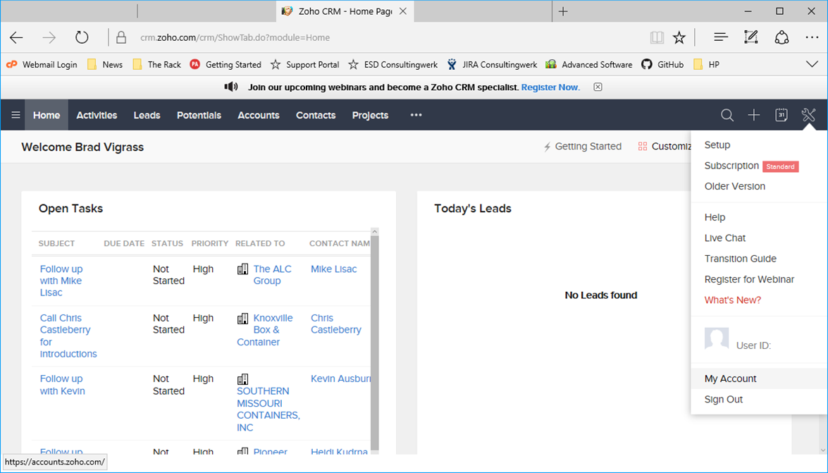

## Active Authtokens

Select the ***“Active Tokens”*** application icon from the table of those available on the screen.

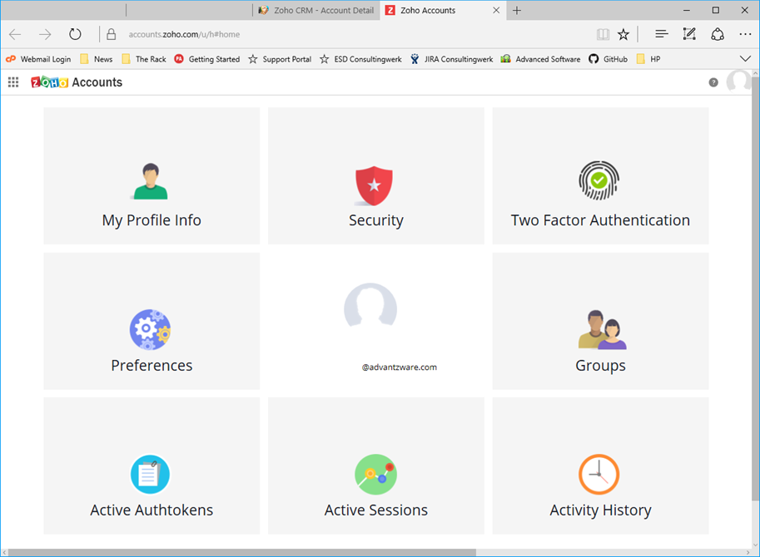

Locate an *Authtoken* whose *Scope* has access to “***crmapi”***. Then, copy this value by highlighting the value and copying to the system clipboard.

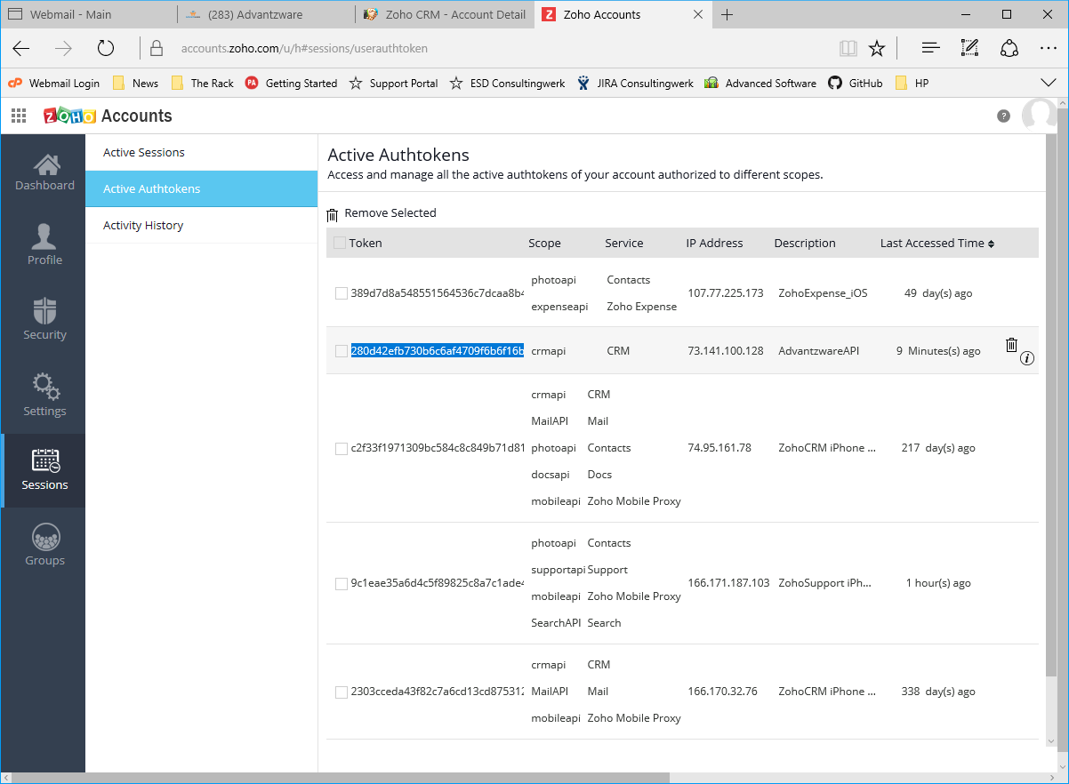

This can be accomplished either with the ***“Control-C”*** method on the keyboard, or by ***“Right-Clicking”*** on the highlighted portion and choosing ***“Copy”*** from the drop-down menu.

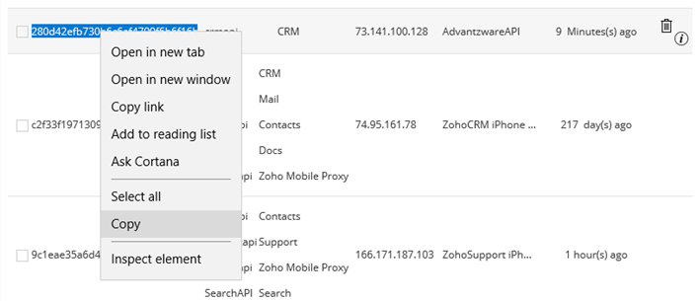

## Advantzware System – Customer Maintenance

### Open Customer File Maintenance Screen

Navigate to Advantzware’s Customer Maintenance program. The *Customer File Maintenance* screen is located in the following Menu Path: Accounts Receivable -> File Maintenance for Customers -> Customers. Alternatively, the user can quickly get to this screen using the Hot Key combination: ***[“A” – “F” – “1”]***.

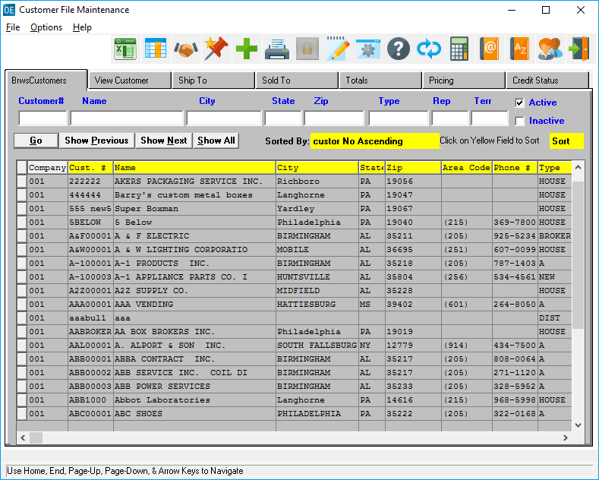

### CRM Icon

Click on the ***“Handshake Icon”*** at the top of the screen in order to invoke the ZoHo CRM interface.



Please Note: If this is the first time you are attempting to access CRM, then the following error message will appear on the screen. This is necessary in order to *Auto Create* the ***“N” – “K” – “1”*** value “*CRMAuthToken”*.

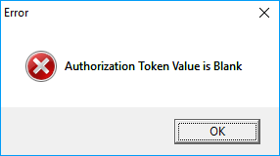

### N-K-1 CRMAuthToken

Navigate to Advantzware’s System Control program. The *System Control Parameters Maintenance* screen is located in the following Menu Path: Network/System Administrator -> K-Control Parameters -> System Control Parameters. Alternatively, the user can quickly get to this screen using the Hot Key combination: ***[“N” – “K” – “1”]***.

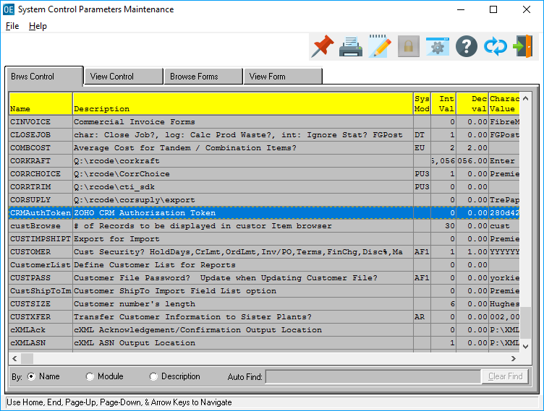

On the *Browse Control* tab, which is the first to open, the user may scroll though the list of available System Control programs for the desired system control. Alternatively, the user may use the *Auto Find* field at the bottom of the screen to search for any program that they wish to use in order to narrow down their selection.

For these purposes, the user must choose the *“CRMAuthToken”* program.

### Paste AuthToken

The user should now paste the AuthToken code that they took from their ZoHo session. To do so, place the mouse cursor in the *Character Value* field, and press ***“Control-V”*** on the keyboard.

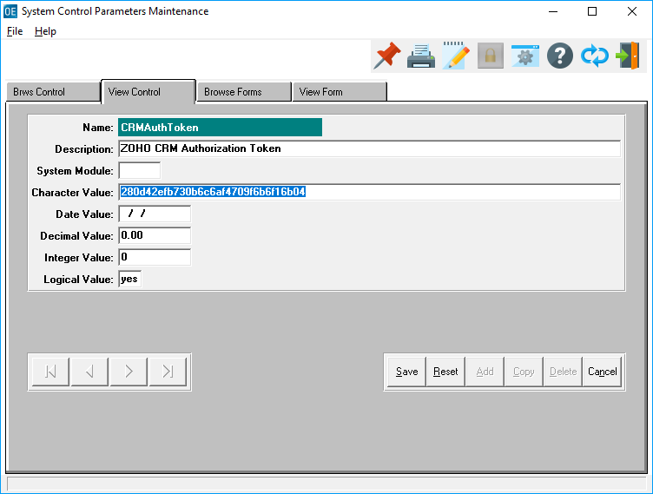

## ZoHo Accounts

Go back to your crm.zoho.com session. Navigate to the *‘Accounts’* page by clicking on the ***“Accounts”*** tab at the top of the screen.

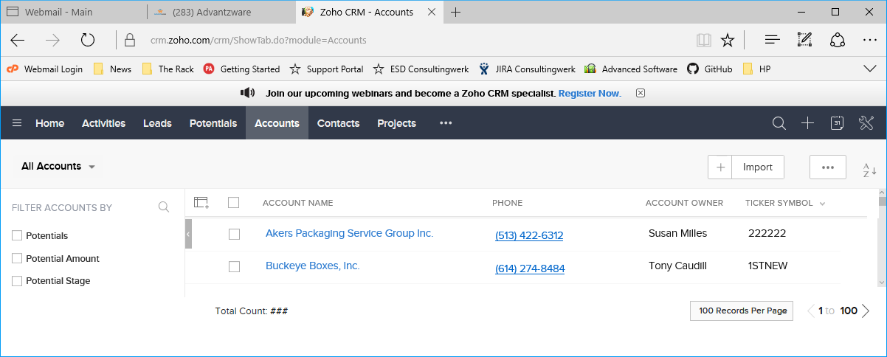

### Select Account

Select a CRM ZoHo Account that is to be uploaded into Advantzware.

A *Customer Code* value needs to be entered into “*Ticker Symbol*” field. This value is this Account’s (Customer’s) designated Customer Code.

In this example, Buckeye Boxes, Inc. has been selected. Click “***Edit***” and scroll down to the “*Ticker Symbol*” field. In this case, Buckeye’s Customer Code is entered as “*Buckeye*”.

Please Note: This value needs to be unique because the CRM interface matches the “*Ticker Symbol*” value against those found in Advantzware. A match will indicate it is an update from CRM. A unique value indicates it is potentially a new Account to be Added to Advantzware.

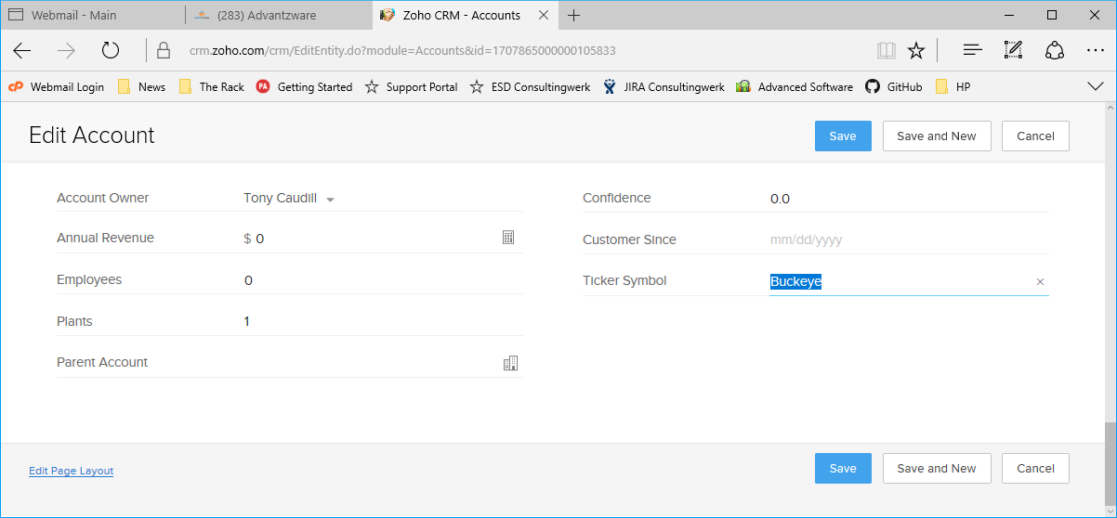

### Repeat as Necessary

Repeat the above steps for any and all Accounts (Customers) which are to be uploaded into Advantzware.

## Return to Customer Maintenance

### Open Customer File Maintenance Screen

Return to Advantzware’s Customer Maintenance program. The *Customer File Maintenance* screen is located in the following Menu Path: Accounts Receivable -> File Maintenance for Customers -> Customers. Alternatively, the user can quickly get to this screen using the Hot Key combination: ***[“A” – “F” – “1”]***.



### CRM Icon

Click on the ***“Handshake Icon”*** at the top of the screen in order to invoke the ZoHo CRM interface.



This will now make a *Web Service* call to the CRM API. Any accounts found with a *‘Ticker Symbol’* that is not blank will be presented for review.

### ZOHO CRM Customers

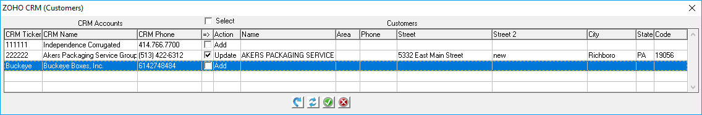

The leftmost columns will show the CRM Accounts, while the rightmost columns will show Advantzware customers as they currently exist.

Any records returned where the *Ticker Symbol* matches an existing Customer will be presented as a potential “*Update*” and have the “*Update*” Action pre-checked. Any CRM Accounts without a matching Customer will appear as a potential “*Add*” Action, but will not be pre-checked.

#### Apply Selected Sections

The ***“Blue Arrow Icon”*** at the bottom of the screen (*Apply Selected Actions*), will allow a preview of the CRM Account values applied to the Customer fields (this does not update any data in Advantzware).

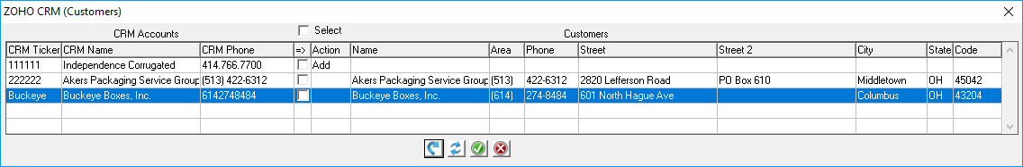

#### Reset

The ***“Blue Refresh Icon”*** at the bottom of the screen (*Refresh*), will cause the process to reload the CRM process. This is useful if the above *Apply Selected Action* was completed, and the preview of any records is not desired.

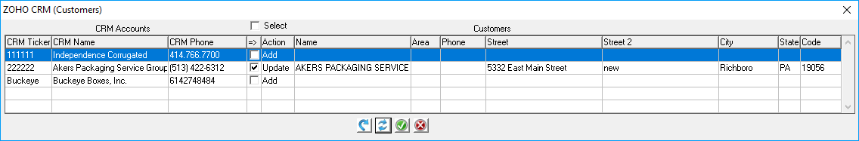

#### Save Selected Actions

The ***“Green Check-Mark”*** at the bottom of the screen (*Save Selected Actions*), will apply any selections and/or previously applied previews to the Advantzware Customers. *Apply Selected Actions* does NOT need to be performed prior to a *Save Selected Actions*. If an *Apply* has been performed, anything updated to the right columns will update to Advantzware. Or simply select any *Update* and/or *Add* to apply those selections to Advantzware.

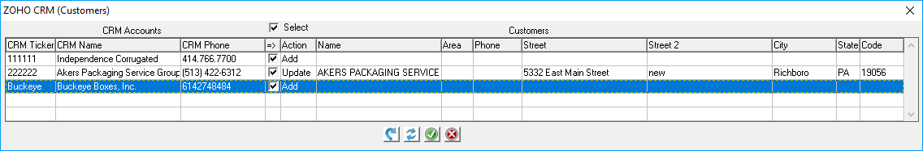

Please Note: Clicking “***Select***” directly above the “*Action*” column will toggle selections *On* or *Off* accordingly.

#### Cancel

The ***“Red X”*** at the bottom of the screen (*Cancel*), will close/exit the CRM interface.

# **Set Up Advantzware CRM ZoHo Contacts**

## Locate Customer in ZoHo

Log in to crm.zoho.com. Navigate to the *‘Accounts’* page by clicking on the ***“Accounts”*** tab at the top of the screen.

Locate the desired Customer whose Contacts are to be uploaded from CRM.

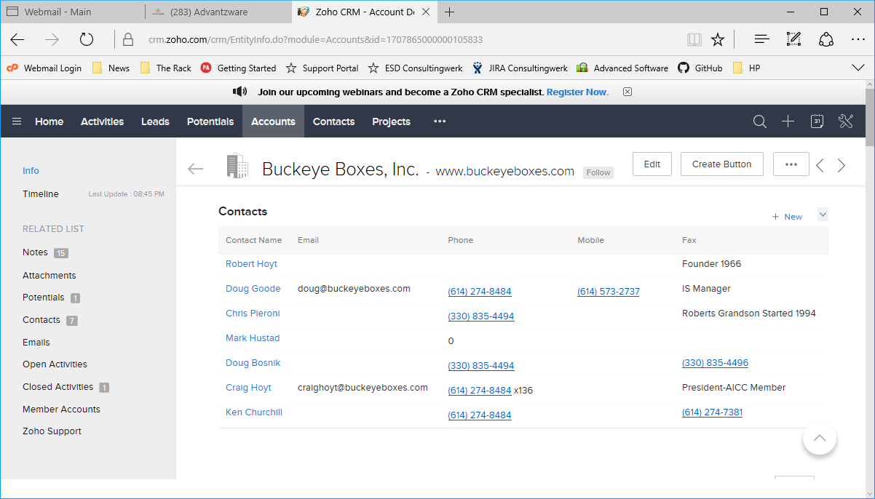

## Advantzware System – Customer Maintenance

### Open Customer File Maintenance Screen

Navigate to Advantzware’s Customer Maintenance program. The *Customer File Maintenance* screen is located in the following Menu Path: Accounts Receivable -> File Maintenance for Customers -> Customers. Alternatively, the user can quickly get to this screen using the Hot Key combination: ***[“A” – “F” – “1”]***.

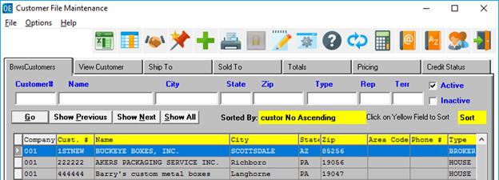

### Phone Info Icon

Click on the ***“Orange Journal with the @ Symbol”*** at the top of the screen in order to access a Customer’s Contacts.



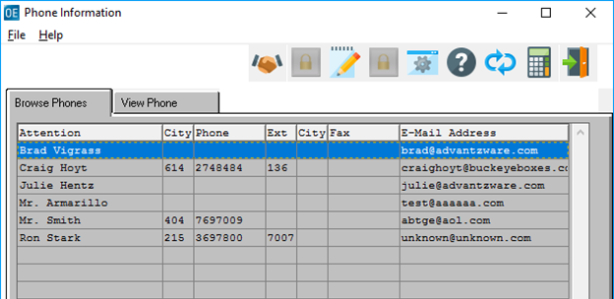

### CRM Icon

Click on the ***“Handshake Icon”*** at the top of the screen in order to invoke the ZoHo CRM interface.



### ZOHO CRM Customer Contacts

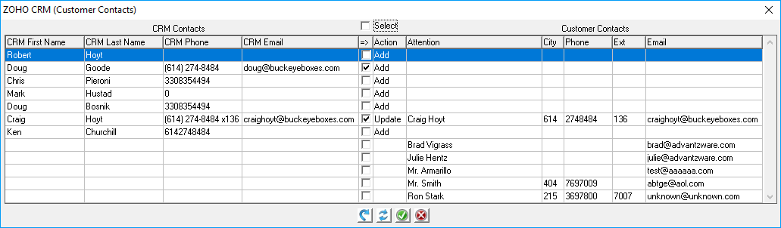

The key aspect of CRM Contacts is that is looks for matching “*Email*” values. Those that match are automatically selected as potential updates.

If no email match is located, it is flagged as a potential add, but will only be auto selected if an email value exists, otherwise blank email records will not be auto selected, but can be manually selected for addition to Advantzware. CRM Contacts are rendered on the left side and any existing Customer Contacts are located in the right-side columns.

#### Apply Selected Sections

The ***“Blue Arrow Icon”*** at the bottom of the screen (*Apply Selected Actions*), will allow a preview of the CRM Account values applied to the Customer fields (this does not update any data in Advantzware).

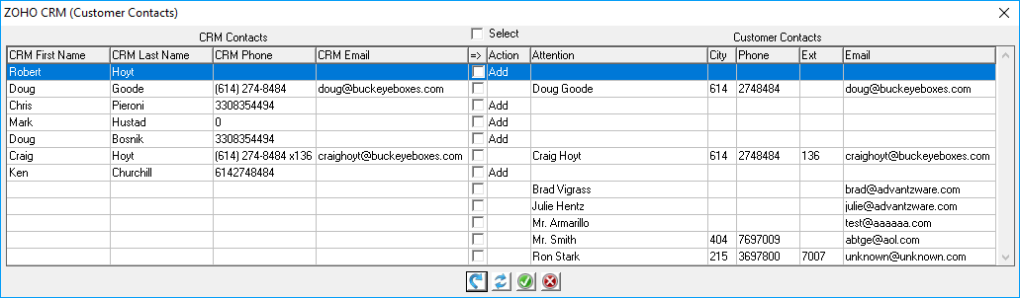

#### Reset

The ***“Blue Refresh Icon”*** at the bottom of the screen (*Refresh*), will cause the process to reload the CRM process. This is useful if the above *Apply Selected Action* was completed, and the preview of any records is not desired.

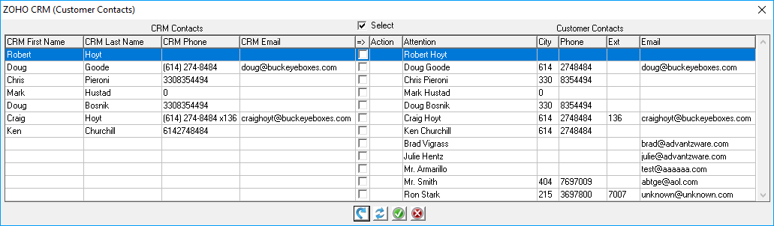

#### Save Selected Actions

The ***“Green Check-Mark”*** at the bottom of the screen (*Save Selected Actions*), will apply any selections and/or previously applied previews to the Advantzware Customers. *Apply Selected Actions* does NOT need to be performed prior to a *Save Selected Actions*. If an *Apply* has been performed, anything updated to the right columns will update to Advantzware. Or simply select any *Update* and/or *Add* to apply those selections to Advantzware.

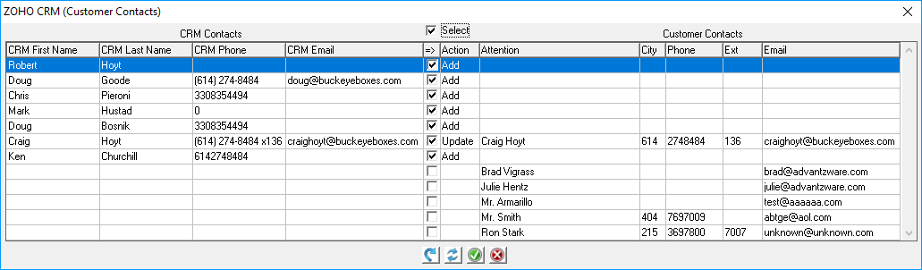

Please Note: Clicking “***Select***” directly above the “*Action*” column will toggle selections *On* or *Off* accordingly.

#### Cancel

The ***“Red X”*** at the bottom of the screen (*Cancel*), will close/exit the CRM interface.

# **Advantzware Open Analytics (AOA)**

## Auto Upload CRM Accounts (Customers)

### Open Advantzware

From anywhere within the Advantzware System, type ***“Control” – “Alt” – “Delete”*** to invoke the AOA Launcher.

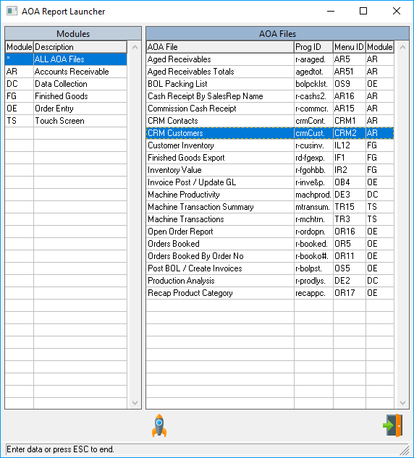

### Launch AOA

Click the ***“Rocket”*** icon after selecting *CRM Customers*. Alternatively, ***“double-click”*** *CRM Customers* to run the parameter screen.

### Report Parameters

Selecting either “*Auto Add New CRM Customers”* and/or “*Auto Update Existing CRM Customers”* will perform the functions selected by silently adding and/or updating CRM Accounts (Customers) from the CRM into the Advantzware System.

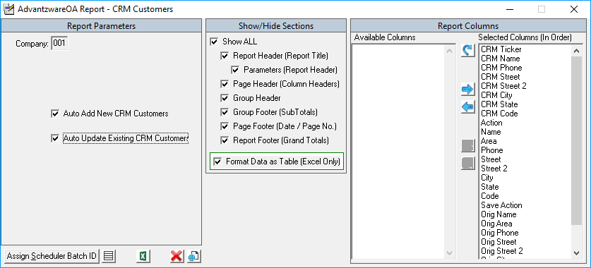

Please Note: See Advantzware Open Analytics (AOA) documentation for instructions on how to navigate AOA Parameter Screens. Any AOA module can be entered into our AOA Scheduler for executing during off hours on a periodic basis, daily, weekly and/or monthly… as frequently as desired.

## Auto Upload CRM Contacts (Customer Contacts)

### Open Advantzware

From anywhere within the Advantzware System, type ***“Control” – “Alt” – “Delete”*** to invoke the AOA Launcher.



### Launch AOA

Click the ***“Rocket”*** icon after selecting *CRM Contacts*. Alternatively, ***“double-click”*** *CRM Contacts* to run the parameter screen.

### Report Parameters

Selecting either “*Auto Add New CRM Contacts”* and/or “*Auto Update Existing CRM Contacts”* will perform the functions selected by silently adding and/or updating CRM Contacts (Customer Contacts) from the CRM into the Advantzware System.

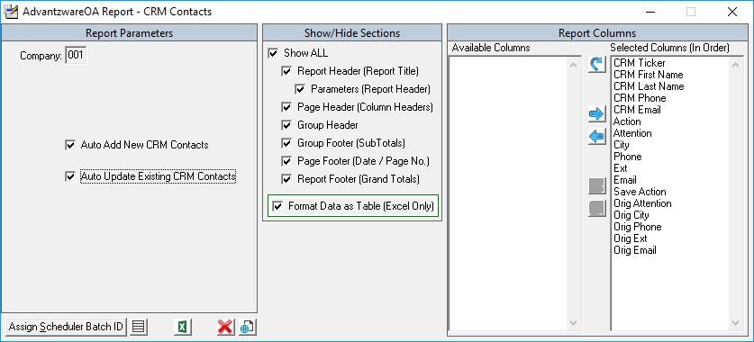

Please Note: See Advantzware Open Analytics (AOA) documentation for instructions on how to navigate AOA Parameter Screens. Any AOA module can be entered into our AOA Scheduler for executing during off hours on a periodic basis, daily, weekly and/or monthly… as frequently as desired.